**Lab-1 Assignment**

**Submitted by:**

**SUBARNA POUDEL  
Student ID: 23002412**

**Submitted to:**

**Professor: Nawaz Chowdhury**

**Subject: Web Development 2**

**Course code: CSD213**

Honesty Statement: “I declare that this submission is my own work in compliance with Sault College Academic Policies.”

**Due date: September 10, 2024 2024**

**Table of Content**

**Assignment Steps** 3

**Assignment Steps-1** 3

**Assignment Steps-2** 4

**Assignment Step-2** 5

# 

# **Assignment Steps**

## **Assignment Steps-1**

Here is my code

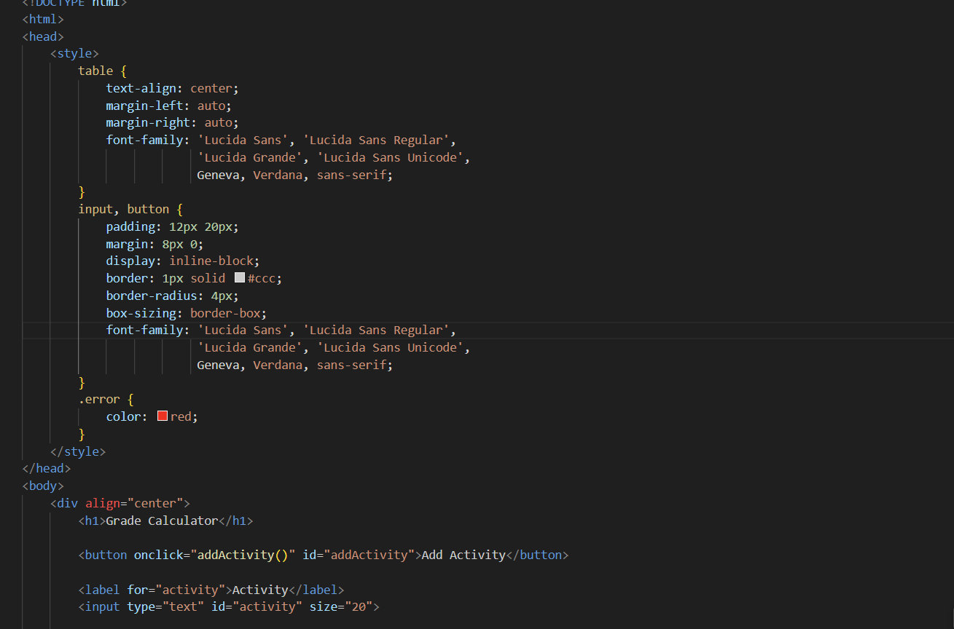

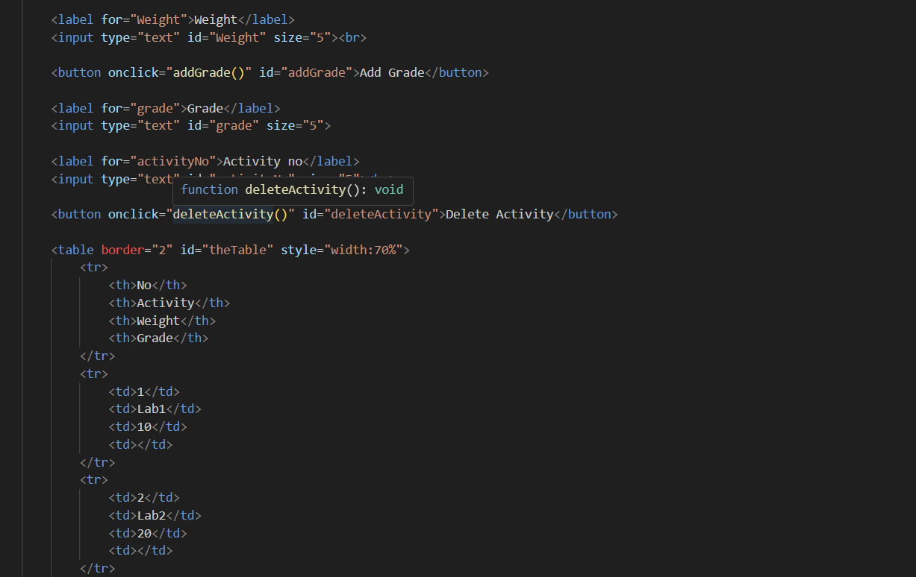

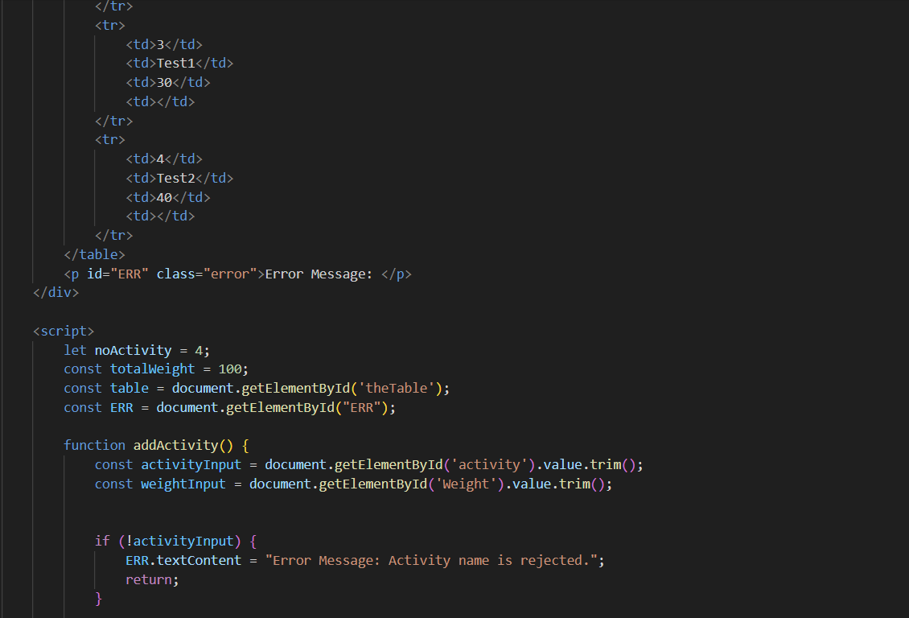

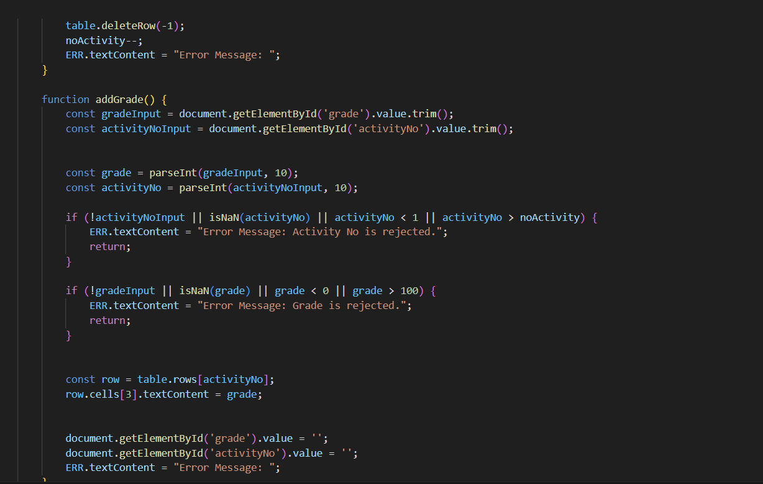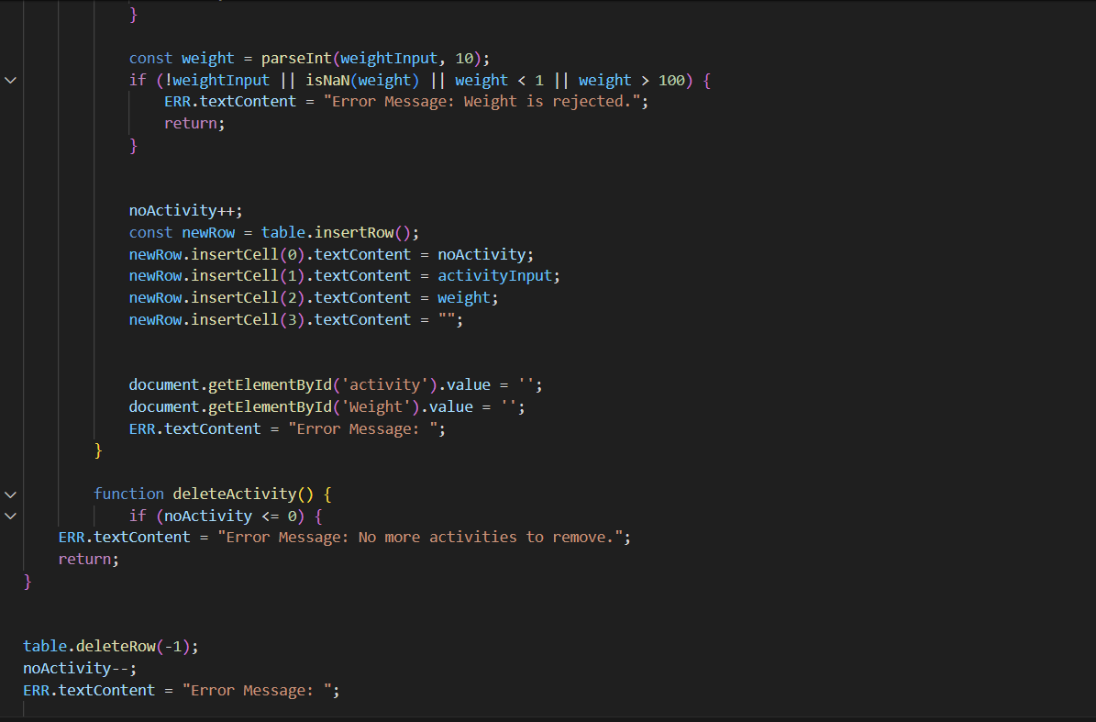

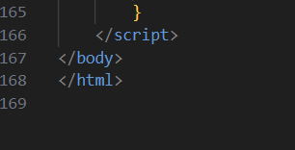

## **Assignment Steps-2**

Here is my output

1. If the Activity is empty, the error message is Error Message: Activity name is rejected.

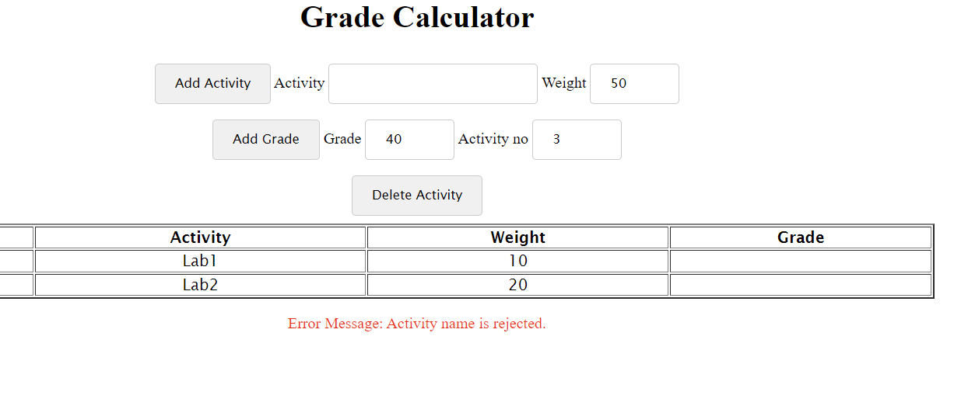

1. If the Activity is empty, the error message is Error Message: Activity name is rejected.

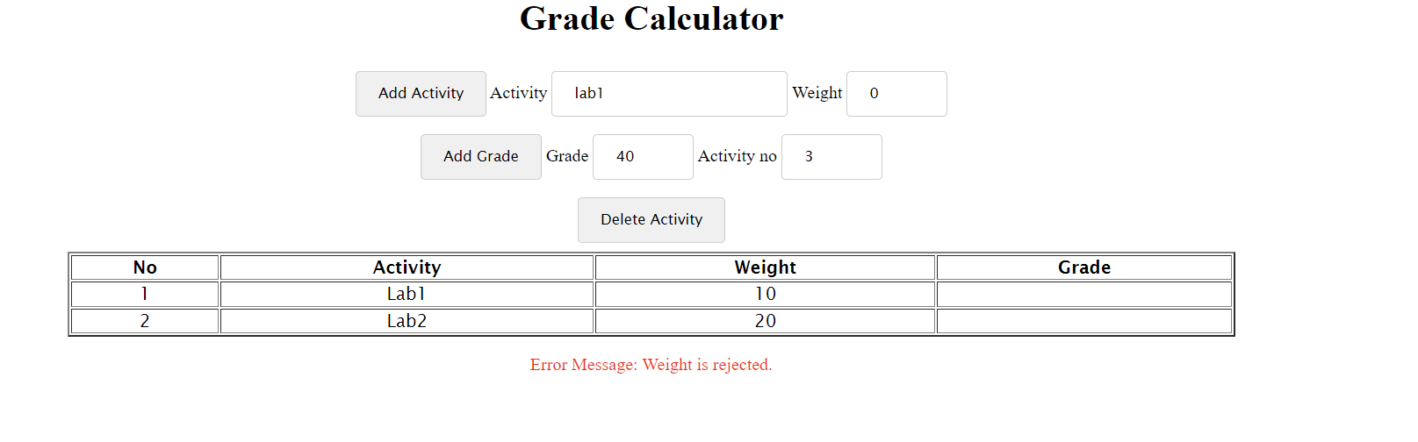

1. [Add Grade] This button adds a grade for the Activity no entered by the user. For example, if the user enters a grade of 40 for Activity no 2,

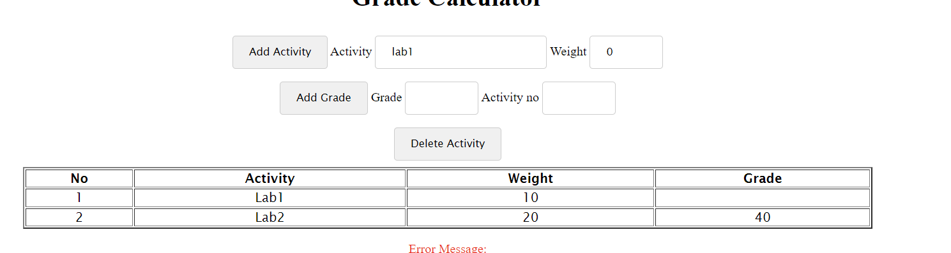

1. If the Grade is empty, or >100, or <0, the error message is Error Message: Grade is rejected.

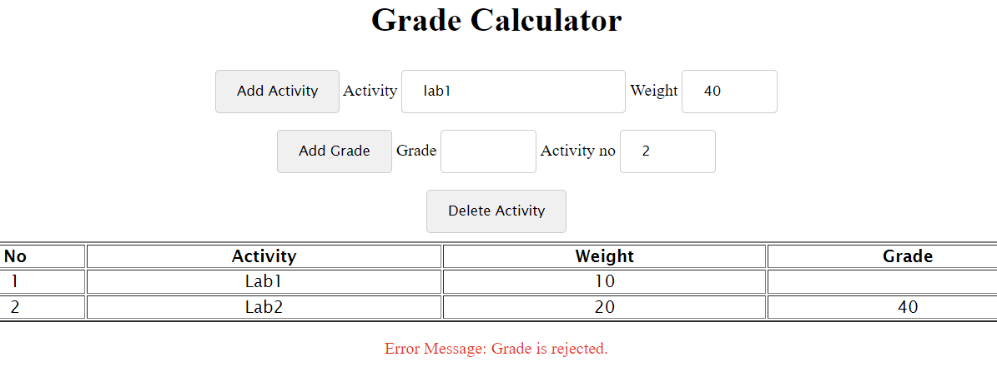

1. If Activity no does not exist, the error message is Error Message: Activity No is rejected.

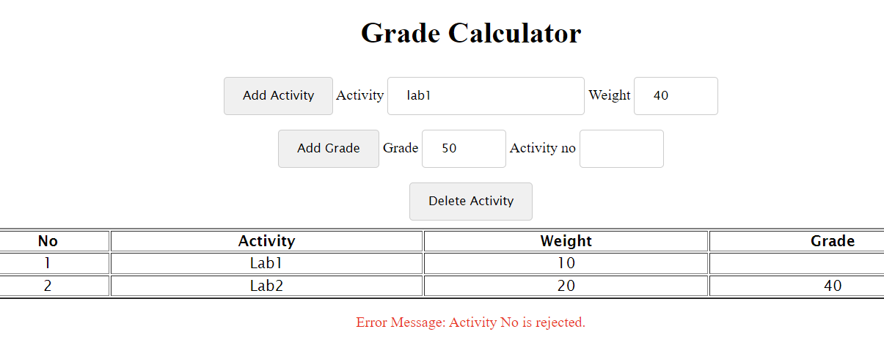

1. This button adds a grade for the Activity no entered by the user. For example, if the user enters a grade of 40 for Activity no 2, the output will look like this:

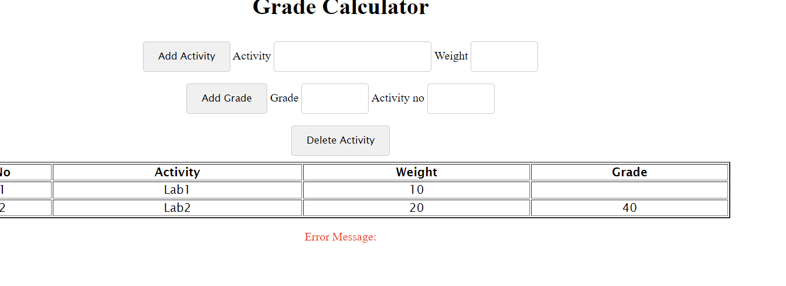

1. If the activity has a grade, the new grade replaces the existing one.

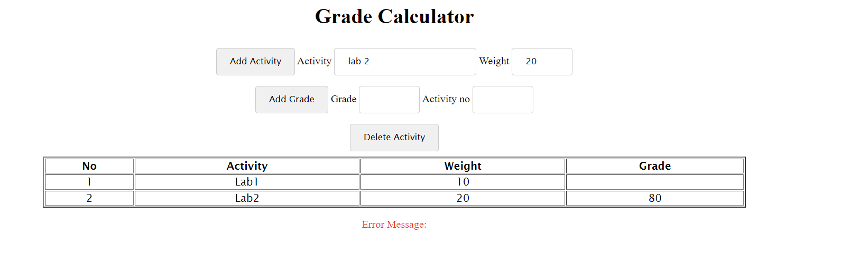

1. After adding the grade, the input field of Grade and Activity no become blank.

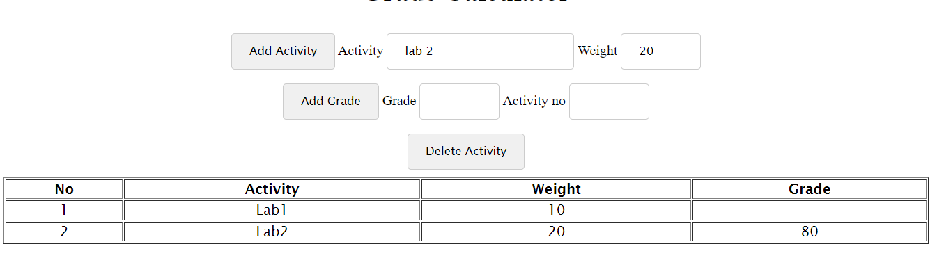

1. After adding the grade, the input field of Grade and Activity no become blank

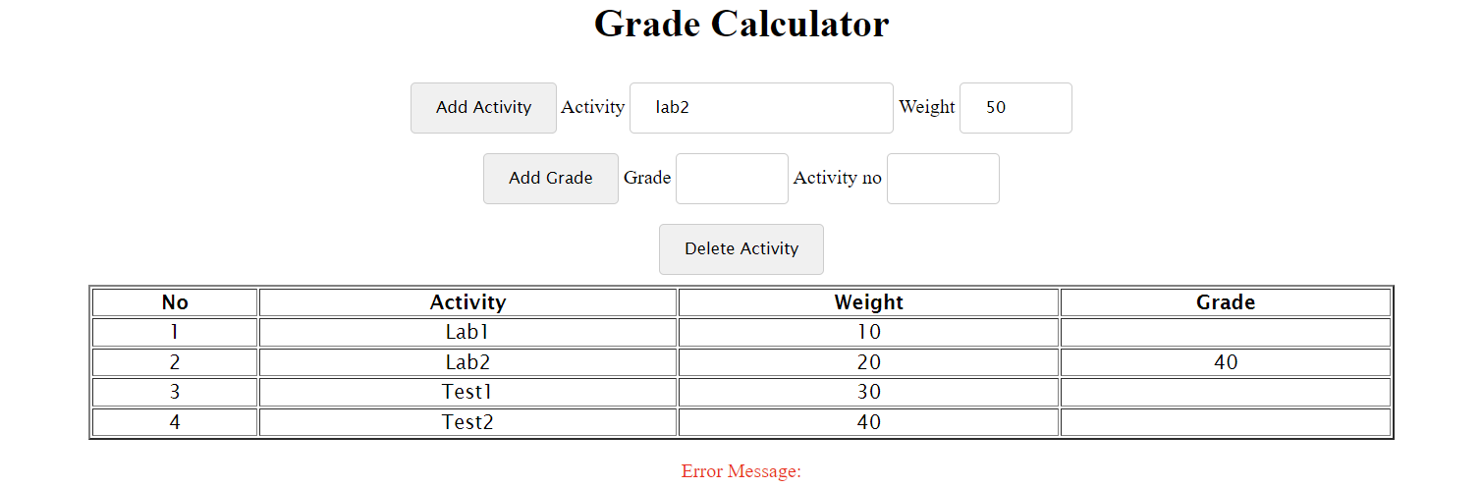

1. If no more activities are left to be deleted, the error message is Error Message: No more activities to remove.

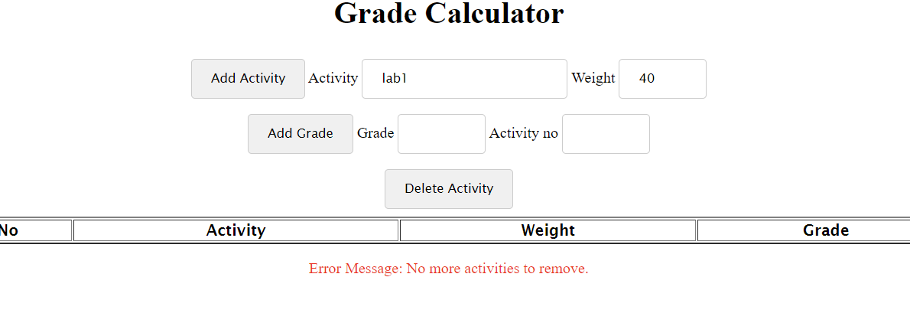

**Thank you.**